

Annual Parish Meeting

June 3, 2018

Agenda

Introduction

Ministry Review and Preview

Resurrection Governance

Description

Vestry Testimonies

Vestry Vote

Moved by Jesus Results and Plans

Financial Review and Preview

Q&A



**Moved by Jesus Allocation**

**$5,685,000 Amount Given**

**$5,000,000 Normal Operations**

December 2015 normal income: $500,000

2016 budget: $2.2 M

2017 budget: $2.3 M

**$685,000 New Initiatives**

$15,000 Local Mission

Replanted – Care for adoptive and foster families

$50,000 Reserves

Used for cash flow fluctuation (Jan-Nov vs Dec)

Emergencies (never used)

$70,000 Strategy, Vision, and Communication

Align staff, money, web, & resources with vision

New Possibility: Redirect $50,000 to Reserves

$50,000 Church Planting

Matching grants for Church Plants and Planters

Training Residents

$75,000 Formation

RezGroups (spent 2015-2017)

$425,000 Facility

Multiuse

Sanctuary Improvements – Shades & Lights

Next Generation – RezKids, RezYouth



2018 Remodel Construction Plan

$102,000 Sanctuary shades and lights

Including Narthex, All Saints Chapel, and Acts 1 Room shades

Lights for Vigil, etc.

Already spent

$252,000 RezKids Room Expansion

Combine RezKids Worship with Sassafras

Double the size of three Shepherd Rooms

Provide restroom for 3’s and 4’s

Replace Sassafras with 2 Shepherd-size rooms in warehouse

Difference: 1 more room than before, but much more space

$45,000 Upgrade St. Gregory Room

Wood accents, Accent lighting, Skylight, 18” stage

Sound and lights

New Chancel Curtains; old curtains to Gregory for sound

$6,000 Make North Activity Center Safer

Movable vinyl/net curtain to separate hallway from gym

$20,000 Contingency

**$425,000 TOTAL = Facility amount from Moved by Jesus**

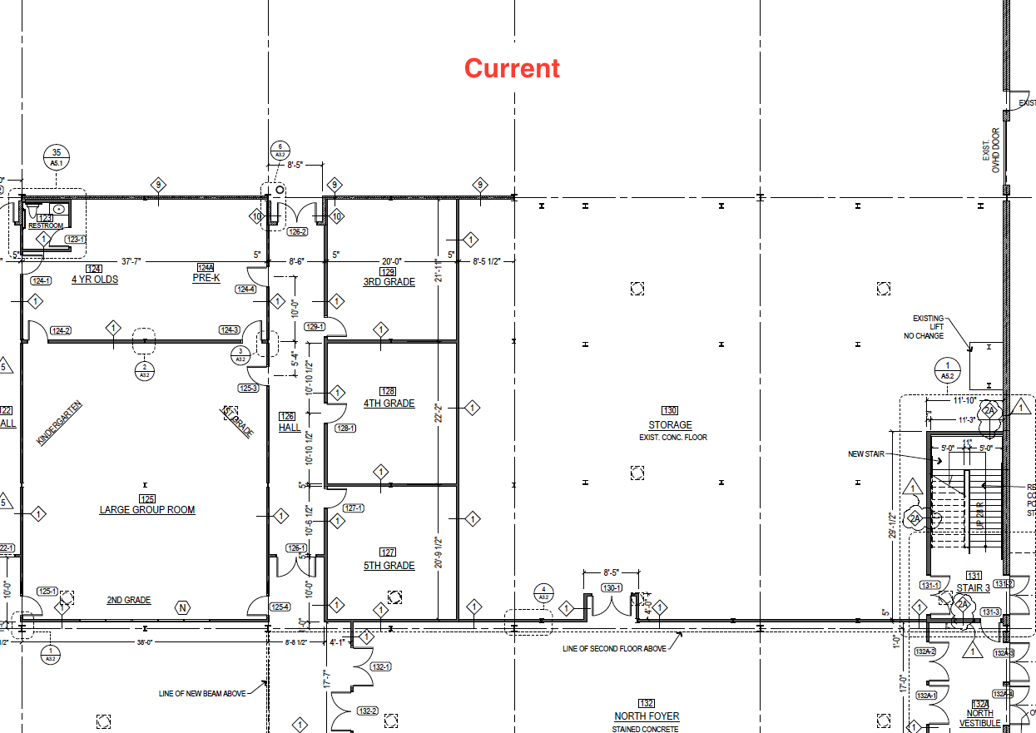

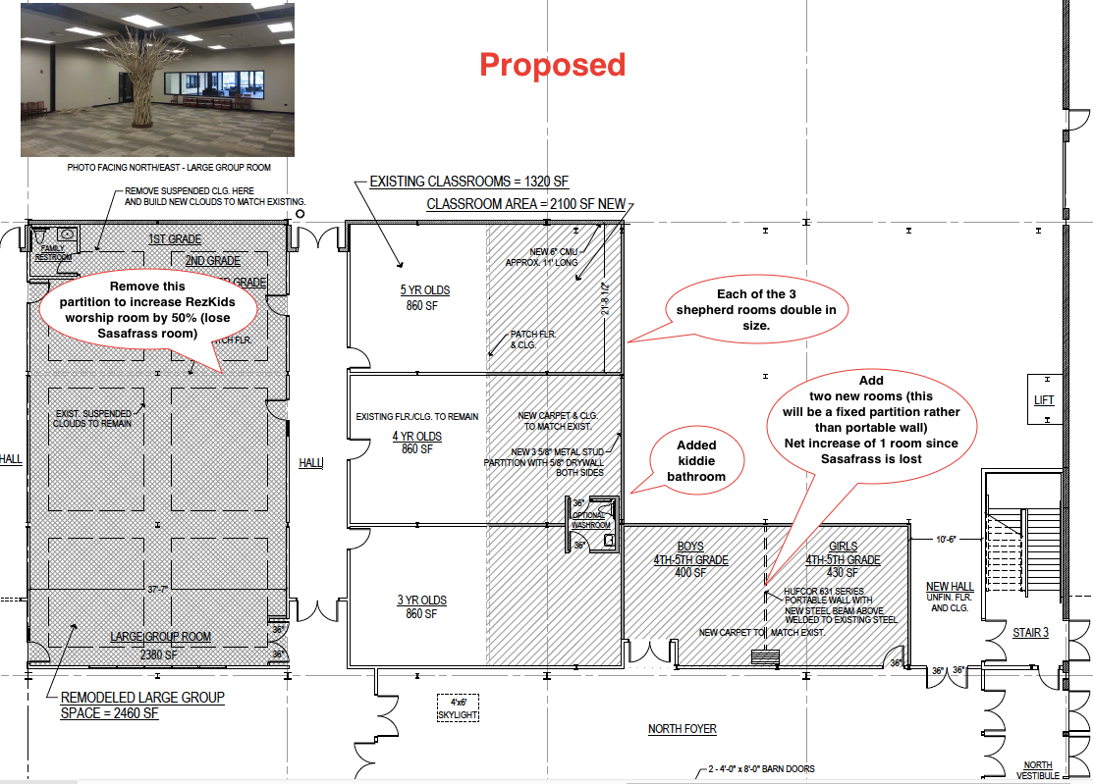

Financial Report (Jan-April 2018) and Preview (July 2018-June 2019)

